Source Code

using System;

using System.Collections.Generic;

using System.Linq;

using System.Text;

using System.Threading.Tasks;

using System.Windows;

using System.Windows.Controls;

using System.Windows.Data;

using System.Windows.Documents;

using System.Windows.Input;

using System.Windows.Media;

using System.Windows.Media.Imaging;

using System.Windows.Navigation;

using System.Windows.Shapes;

namespace WPFRegisterStudent

{

/// <summary>

/// Interaction logic for MainWindow.xaml

/// </summary>

public partial class MainWindow : Window

{

Course choice;

int total = 0;

public MainWindow()

{

InitializeComponent();

}

private void Window_Loaded(object sender, RoutedEventArgs e)

{

Course course1 = new Course("IT 145");

Course course2 = new Course("IT 200");

Course course3 = new Course("IT 201");

Course course4 = new Course("IT 270");

Course course5 = new Course("IT 315");

Course course6 = new Course("IT 328");

Course course7 = new Course("IT 330");

this.comboBox.Items.Add(course1);

this.comboBox.Items.Add(course2);

this.comboBox.Items.Add(course3);

this.comboBox.Items.Add(course4);

this.comboBox.Items.Add(course5);

this.comboBox.Items.Add(course6);

this.comboBox.Items.Add(course7);

this.textBox.Text = "";

}

private void button_Click(object sender, RoutedEventArgs e)

{

choice = (Course)(this.comboBox.SelectedItem);

bool result = false;

if (listBox.Items.Contains(choice.ToString()) == true)

{

result = true;

label3.Content = "You have already registered for this "+choice.getName()+" course";

}

if (total >= 9 == true)

{

label3.Content = "You can not register for more than 9 credit hours.";

}

if (total >= 9 == false && result == false)

{

total += 3;

textBox.Text = total.ToString();

listBox.Items.Add(choice.getName());

label3.Content = "Registration Confirmed for course " + choice.getName();

}

// choice = (this.comboBox.SelectedItem.ToString());//assigns variable for user to choose from list of courses in combobox

// if (this.listBox.Items.Contains(choice)) //executes when user tries registering for a course

// {

// this.label3.Content = "you have already registered for this" + choice.ToString() + "course."; //prints error message you have already registered for this when user messages for the same course

// }

// if (total >= 9) //allows user to add more courses as long as number of credits do not exceed 9

// {

// this.listBox.Items.Add(choice);// adds course choice to listBox to user can see what courses they have registered for

// total += 3;// totalcredit increases by 3 increments in textbox

// this.textBox = Convert.ToString(total); // converts int value of numOfCreditsnto a string

// this.label3.Content = "Registration Confirmed for course" + choice.ToString() + "."; //prints confirmation message for user

// }

// else

// //only executes if credit hours reach >=9

// this.label3.Content = "you can not register for more than 9 credit hours.";// prints error message that user can't register for more than 9 credit hours

}

private void comboBox_SelectionChanged(object sender, SelectionChangedEventArgs e)

{

}

}

}

The screenshot displays a clear image of the program's interface, with all buttons and options in their correct places showing that the program is running correctly.

this.comboBox.Items.Add(course1);  
            this.comboBox.Items.Add(course2);  
            this.comboBox.Items.Add(course3);  
            this.comboBox.Items.Add(course4);  
            this.comboBox.Items.Add(course5);  
            this.comboBox.Items.Add(course6);  
            this.comboBox.Items.Add(course7);

On the screen, in comboBox, a drop-down menu shows all the available classes for courses. Because the if statement is accepted A confirmation message in red text confirms the student's registered class selection. The chosen class is also displayed for the student to view in the listBox. The total is also being increased by increments of three to show each class has 3 credit hours and student can register for classes until they reach 9 credit hours so a if statement is used to see if the operation occurs.

}  
            if (total >= 9 == false && result == false)  
            {  
                total += 3;  
                textBox.Text = total.ToString();  
                listBox.Items.Add(choice.getName());  
                label3.Content = "Registration Confirmed for course " + choice.getName();  
            }

this.listBox.Items.Add(userchoice);

The selected course will be added to the list box so that users can easily view which courses they have registered for.

textBox.Text = total.ToString();

The textBox contains the total number of credit hours that the student is enrolled in.

int 0; is the initial credits when the box is empty and

Total +=3 means every time a course is added to the text box the course credit hours will be added on to the total credit hours.

private void button_Click(object sender, RoutedEventArgs e)  
This is the button that the user clicks to enroll in their chosen class

choice = (Course)(this.comboBox.SelectedItem);  
code is taking the item from the textbox and casting it to course object.

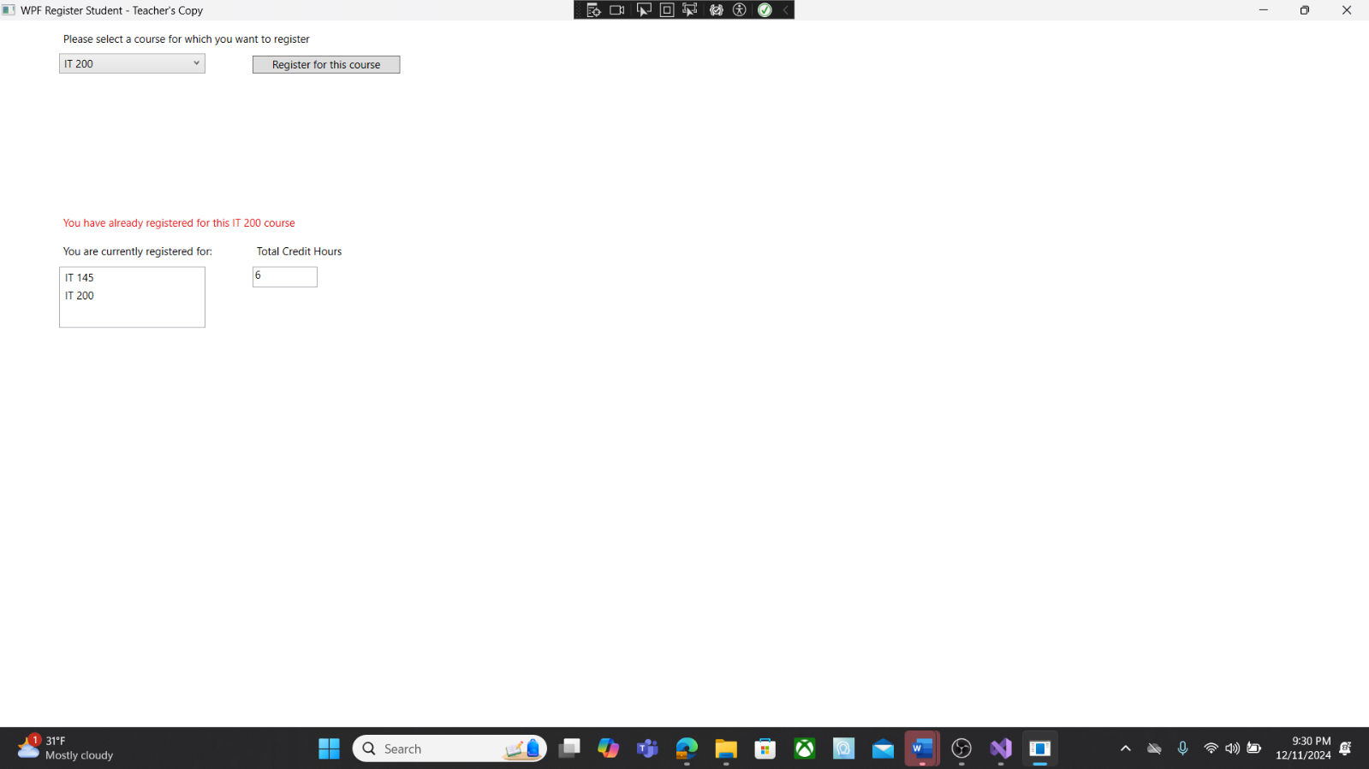

To demonstrate the proper functioning of the program in the event of a duplicate course, a screenshot is shown. The screenshot provides a clear and detailed view of the program's interface with all buttons and options displayed accurately, confirming that the program is running correctly.

bool result = false;  
            if (listBox.Items.Contains(choice.ToString()) == true)  
            {  
                result = true;  
                label3.Content = "You have already registered for this "+choice.getName()+" course";  
            }  
The if statement and bool are used to prevent the user from registering for the same course twice, as it is not allowed in the program. If the user attempts to do so, a message will be displayed informing them that they have already registered for their selected course.

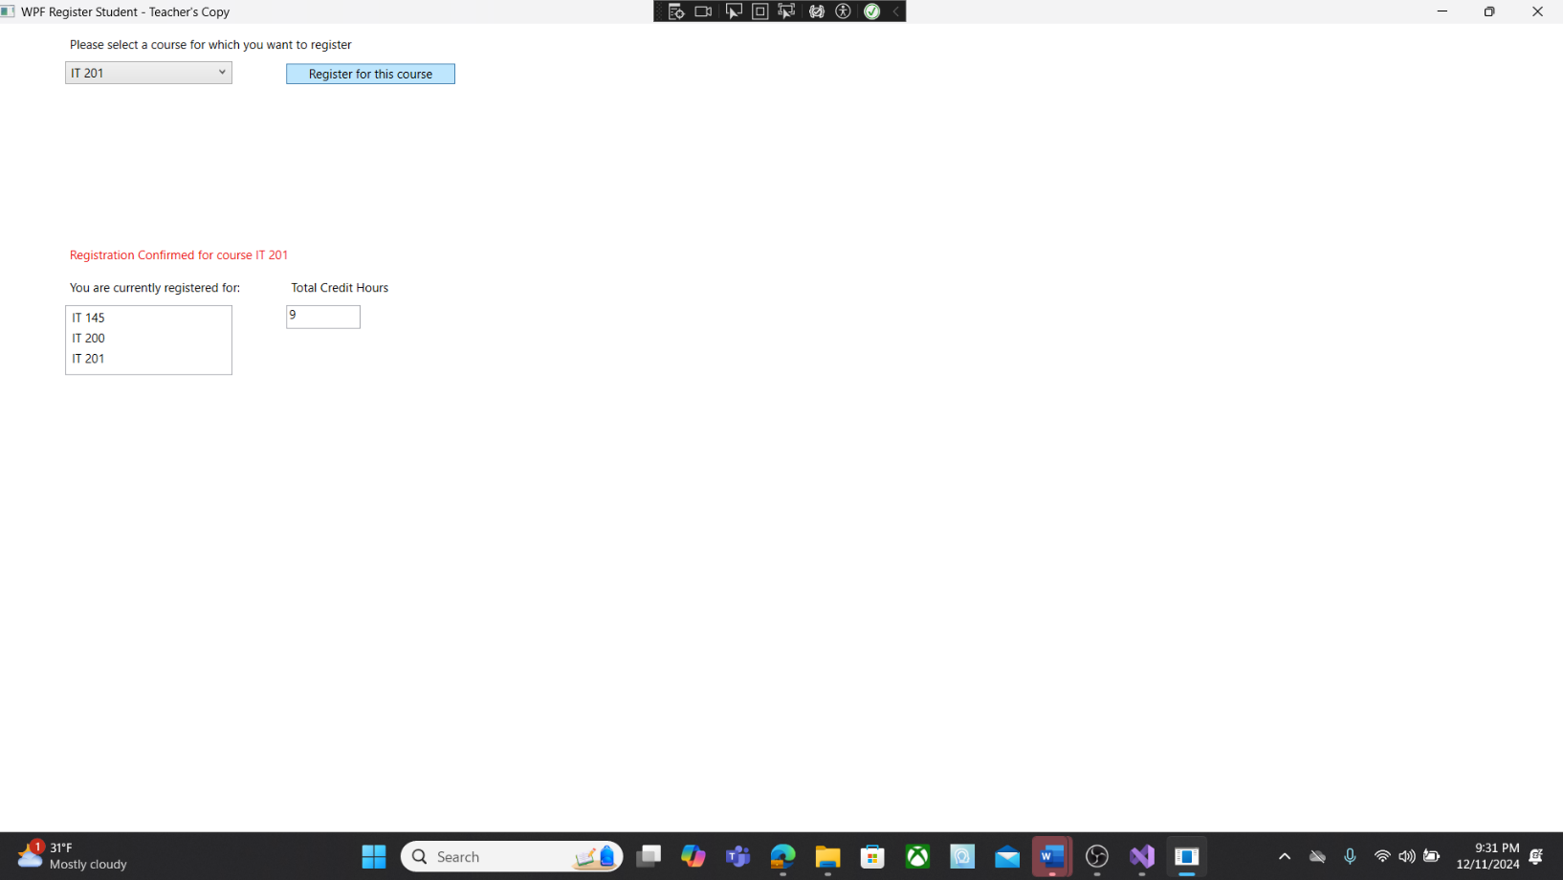

The interface in this screenshot is a clear indication that the program is functioning correctly, as all buttons and options are laid out in their proper places. It also confirms that the student has successfully registered for 9 credit hours without encountering any problems.

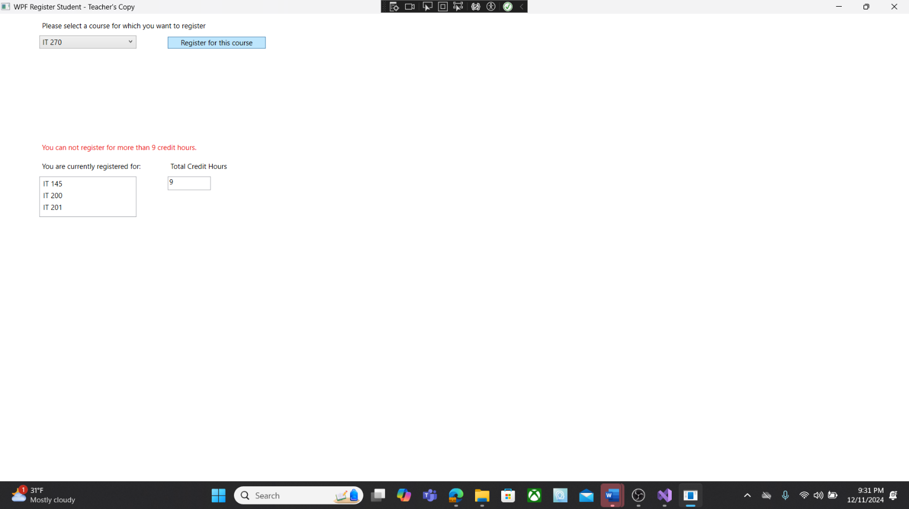

This screenshot displays the program's interface, confirming that all buttons and options are in their proper places and indicating that the program is functioning correctly. This particular image demonstrates that a user is unable to register for any additional courses.

            if (total >= 9 == true)  
            {  
                label3.Content = "You can not register for more than 9 credit hours.";

In order to restrict students from registering for more than 9 credit hours, an if statement and bool variable are implemented. Students can only register for classes until they reach 9 credit hours. Once they exceed this limit, the program will display a message stating "You cannot register for more than 9 credit hours" to inform the user that they have reached the maximum allowed credit hours.